What is Myopia?

Myopia, also commonly known as near-sightedness, results in a person not being able to see distance objects without the use of glasses or contact lenses.

The most troubling aspect of myopia is the rapidly increasing number of people suffering from this condition and the increasing number of patients with high myopia (> -5.00 Diopters).

World-wide Myopia Numbers
2000: - 22% of the world population myopic (1.34 billion people)
- 2% of the population being classified as high myopia.

2050 (estimated from current rates of increase)
- 49% of the population (49 billion people) myopic
- 9.7% of the population with high myopia

The theories behind why we are seeing such a dramatic increase in prevalence and severity of myopia is multi-factorial; family history, ethnicity, diet, time outdoors, near work, and current vision correcting options have been shown to contribute.

At this time it is believed that the cause of myopia ~70% genetic and ~30% environmental.

Why is this important?

The more myopic (near-sighted) an eye progresses, the more dependent on vision correction (glasses and contact lenses) a person becomes.

Even more importantly, as an eye becomes more near-sighted, the axial length or size of the eye increases. As an eye becomes larger, the structural and sensory components of the eye (sclera, retina) are forced to stretch to accommodate this increased surface area. This stretching can result in weakening of the ocular tissue and the risk of serious ocular health complications greatly increases later in life.

Relative Risk of Ocular Disease as Myopia Increases

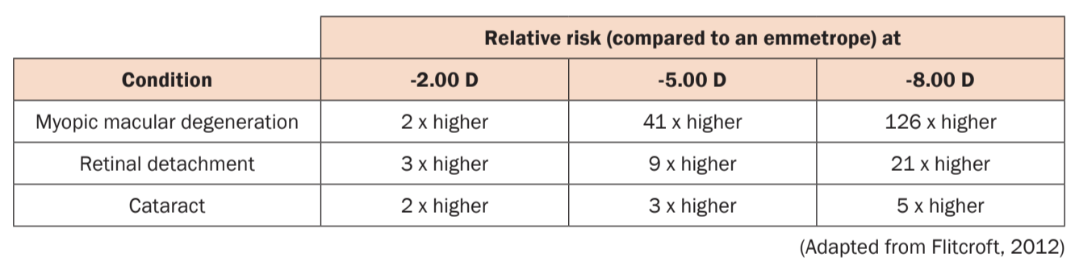
What can be done?

Myopia Management is one of the newest and most exciting areas in Optometry and eye-care. For many years, the only treatment offered for patients becoming more and more near-sighted was to prescribe stronger prescription glasses and contact lenses and hope that one day the progression will stop.

Myopia tends to progress most rapidly through our adolescent and teenage years. This happens as our bodies are rapidly growing over this time period and the eye is growing as well (increasing axial length).

The last decade has shown a concerted effort by researchers to identify evidence-based treatment options to slow or halt myopia progression. Current treatment options that have been shown to slow myopia progression include:

- Orthokeratology (night time contact lens wear)
- Daily, Multi-focal contact lenses
- Eye drops (Atropine)
- Multi-focus glasses

The rate of success of these treatment options has varied from patient to patient, with the most effective treatments (Orthokeratology, Daily Multi-focal lenses and Atropine) resulting in ~50% slowing of progression, with a range of slowing from 30-80% depending on specific treatments and patient characteristics in each of the studies.

Our Approach.

Our goal at Family Focus Eyecare is to select a treatment option specific to each patient that is going to best slow or stop their progression of myopia, correct their vision and offer the best quality of life impact in regards to that patient’s needs.

A Myopia Management Assessment is performed prior to initiation of treatment. This initial assessment allows us to take detailed measurements of the eye to determine baselines and the opportunity to discuss current behaviors and habits and assess other risk factors. This allows us to make a personalized, treatment recommendation for your child.

“What to expect during your Myopia Assessment”

Myopia Management at Family Focus Eyecare is not simply a single treatment recommendation, but a management plan that encompasses regular monitoring (every 3-6 months) and an evolving strategy based on treatment success and guided by the most recent scientific research and clinical guidelines.

Our optometrists are dedicated to bringing the most up-to-date treatment options to our Saskatoon patients and continued involvement in the international Myopia Management community.

Myopia Management Resource Center

Parents Portal

My Kids Vision

Additional Information on Myopia for Parents

Brien Holden Vision Institute

Additional Studies and Journal Articles

Efficacy comparisons of 16 interventions for myopia control in children: A network meta-analysis (Huang et al, 2016)
https://www.ncbi.nlm.nih.gov/pubmed/26826749

Overview of Orthokeratology, as published in the American Journal of Ophthalmology (Koffler and Sears, 2015)
https://www.ncbi.nlm.nih.gov/pubmed/24238200

The Safety of Orthokeratology, as published in Eye and Contact Lens (Liu and Xie, 2016)
https://journals.lww.com/claojournal/Fulltext/2016/01000/The_Safety_of_Orthokeratology_A_Systematic_Review.6.aspx

The Safety of Soft Contact Lenses in Children, as published in Optometry and Vision Science (Bullimore, 2017)
https://www.ncbi.nlm.nih.gov/pubmed/28514244

Time spent in outdoor activities in relation to myopia prevention and control: a meta-analysis and systematic review (Xiong et al, 2017)
https://www.ncbi.nlm.nih.gov/pubmed/28251836

Effect of outdoor activity on myopia, as published by the American Medical Association (Mingguang et al, 2015)
https://jamanetwork.com/journals/jama/fullarticle/2441261

Flitcroft, D. I. "The complex interactions of retinal, optical and environmental factors in myopia aetiology." Progress in retinal and eye research 31.6 (2012): 622-660.

